Blog App Software Requirements

# **Goals**

1. create a blog to be able to share stories and knowledge with others

# **User Stories**

1. as a viewer, I want to see a list of blog posts so that i can see the vlog and topics for me to choose
2. as a viewer, I want to an individual blog post so that i can read all of its content
3. as an admin, I want to be able to add a new post so that i can easily add content to my blog

# **User Flow**

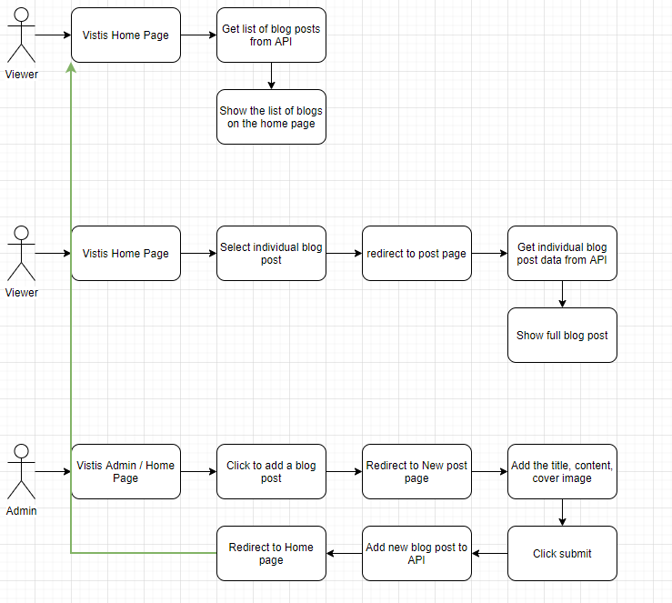

# **Business Requirements**

TASK: Complete New Post Page Requirements

* Pages
  + home page
  + individual blog page
  + new post page
* Home page
  + display user profile image
  + display list of blogs with Title, Date, Content
  + limit the blog text to a certain height
* Individual blog post page
  + show the cover image, title, content, date added
  + allow the user to go back to home page
* New post page
  + show the blank boxes to create a new post
    - blank title
    - blank content
    - select a cover image
    - store the added date

# **Technical Requirements**

* Front End using JavaScript
* Back End using NodeJS
  + Rest API
* Database
  + JSON
* API Endpoints
  + Get listed of blog posts
    - "api/posts"
  + Get individual Blog
    - "api/post/:post_id"
  + Post blog post
    - "api/posts"